**Information**

|  |  |  |
| --- | --- | --- |
| **CRIM ID** | **Title** | **Workstream** |
| C0449 | Service Delivery Manager Lobby – v0.1 | Service Management |

**Revision History**

|  |  |  |  |
| --- | --- | --- | --- |
| **Revision** | **Date** | **By** | **Remarks** |
| 0.1 | 11/01/2021 | Erika Sukevic | Base spec |
| 1.0 | 24/05/2021 | Erika Sukevic | Monitored/not monitored logic |
| 1.1 | 16/07/2021 | Erika Sukevic | Monitored/Not monitored logic additional |
|  |  |  |  |

# CRIM Narrative

We need a new lobby called Service Delivery Management which would include the following information:

* Revenue by work type
* Active users (Monitored/Not Monitored)
* Equipment Installed
* SLA missed by reason
* WOs awaiting Warehousing
* Materials dependent: ready to assign
* Materials dependent: ready to transfer
* Open jobs
* Overdue WOs
* % completed tasks within SLA
* WO about to breach the SLA

Lobby should have default filter to show only service contract or WOs where contract type = MS.

It also should have ability to filter by date range, contract ID and region representative.

Representative can be found on the customer screen.

Date range should pick up Entry Date on the WO.

Contract ID:

### Revenue by work type

We need a pie chart which would show the total revenue of the contract(s) by work type.

Firstly, find all work tasks which belong to the lobby filter eg specific contract.

Then check what work type does this task has.

Finally find all Invoiceable sales lines on the work task and sum their Sales Price Amount/Curr values.

The lobby element should sum all work tasks sales prices by the task work type.

### Active users (Monitored/Not Monitored)

We need two tiles: first to display the number of monitored and second to display the number of not monitored users on the contract.

To find out which monitored/not monitored users use Functional Object screen, Tunstall Service User Status Tab. Criteria for monitored users:

* Object level is ~~360_SERVICE_RECIPIENT~~ 360_SERVICE_USER
* Service User Status = Active
* Monitored column is ticked

Criteria for not monitored users:

* Object level is ~~360_SERVICE_RECIPIENT~~ 360_SERVICE_USER
* Service User Status = Active
* Monitored column is unticked

You can check to which contract the user belongs to by using Service Lines tab.

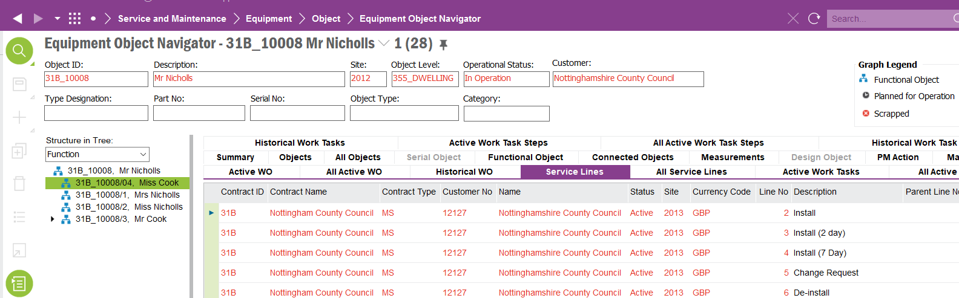

### Equipment Installed

We need a list which would show all parts installed on the contract. The logic should find all functional objects in the structure and check which sales part is selected on the object. The list should have 3 columns: Part No, Part Description and Quantity. Note: if Equipment Quantity field is blank count it as 1. If the part number is the same on the multiple object the lobby element should sum the quantities. If no search criteria are selected for the contract then the list should bring a sum of all parts from all objects.

To find which contract each object belongs to go up on the object structure until Service Lines tab will display service contract. For example, Object ID 31B_E1_57000/320 has a part against it but All Service Lines tab is blank.

This object belongs to 31B_10001. On this object we can see that contract ID is 31B.

### SLA missed by reason

We need a pie chart which would show the number of the work tasks by the SLA missed reason. If possible, the elements of the pie chart should be clickable and bring the Prepare Work Order screen with the selected records.

The pie chart needs to count all work tasks where Tunstall SLA data < Actual Finish and sort it by the SLA missed reason. If reason is blank, then on the chart put these work task against “blank” reason.

### WOs awaiting Warehousing

We need a lobby to count how many work tasks cannot be progressed because it is awaiting warehousing team. The lobby should bring all work tasks in status Released where:

1. Work task has open material requisition lines where qty required > qty reserved or
2. Work task has open material requisition lines where parts are reserved, engineer assigned but requisition has no transport task created

Screenshot for option 1:

Screenshot for option 2:

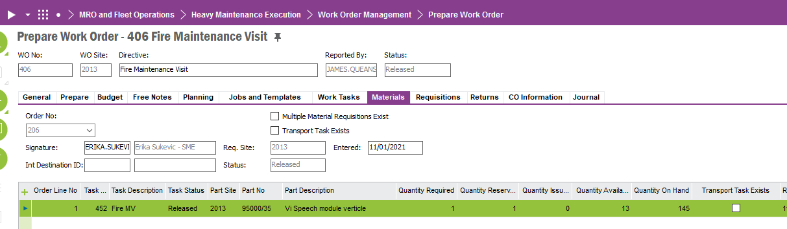

### Materials dependent: ready to assign

We need a tile which would count all unassigned work orders where all material requisition lines associated to the work task are reserved. The material requisition must exist for task to appear on this lobby.

To identify unassigned check Work Assignments tab – it should not have records against it.

Then check the Materials tab. Bring the task to the lobby when all material lines are reserved – where qty required = qty reserved.

### Materials dependent: ready to transfer

We need a lobby tile which would show the count of the assigned but not transferred work tasks which has material requisition attached to it with the transport task in status Picked or Executed.

Work task should have work assignment attached to it, but Sent Date should be blank.

The material requisition which attached to the work task should have associated transport task(s) in status picked or executed.

### Open jobs

We need a tile which would count all open work tasks. Logic should bring records where work task status = New, Under Preparation, Prepared, Released, Work Started.

### Overdue WOs

We need a tile which would count all work tasks where Tunstall SLA date < sysdate.

Tile should only bring work tasks in the following statuses: New, Under Preparation, Prepared, Released, Work Started.

### % completed tasks within SLA

We need a pie chart which will show the % of the work tasks completed within SLA and the ones which are completed outside SLA. If possible, when user put the cursor on the pie chart it should show the count of the work tasks.

The logic should check the Actual Finish date of the task and compare it with the Tunstall SLA. If Tunstall SLA > Actual Finish then bring as within SLA; If Tunstall SLA < Actual Finish then bring as failed SLA.

### WO about to breach the SLA

We need a tile which will count the number of the work tasks about to breach the SLA. The logic should check the Tunstall SLA field and if the sysdate is within 24h of the SLA date then bring these tasks to the lobby. For example, if today is 08/01/21 and Tunstall SLA shows 09/01/21 the task should appear on the lobby. If today is 08/01/21 and Tunstall SLA is 12/01/21 then lobby should ignore this record.

Tiles should only bring work tasks in the following statuses: New, Under Preparation, Prepared, Released, Work Started.

# Design Q&A

# BA/Developer Notes/ Related CRIM

# Technical Proposal

*\*\*\*\* Guidance Notes – Remove prior to submission \*\*\*\**

***********************************************

# Technical Solution

## Technical Process

Lobby Page

Pre-requisites: Deploy the IAL objects following the steps mentioned under deployment instructions section

***********************************************

## Report Components

********************************************

## Known Dependencies

*\*\*\*\* Guidance Notes – Remove prior to submission \*\*\*\**

***********************************************

# Deployment Instructions

Deploy Following IAL objects to the environment. Files are located at the Deliverables Folder (Tunstall Deliverables\EA_SERVICES\IAL OBJECTS)

1. Wos_awaiting_warehouse
2. Wo_about_to_breach
3. Tasks_within_sla
4. Sla_missed_by_reason
5. Revenue_by_work_type
6. Overdue_wos
7. Open_jobs
8. Not_monitored_active_users
9. Monitored_active_users
10. Materials_read_to_transfer
11. Materials_read_to_assign
12. Equipment_installed
13. Completed_tasks_within_sla
14. Completed_tasks_failed_sla

Steps:

* Go to IAL Object Developer Window

Solution Manager/ Business Reporting & Analysis/ Information Access Layer / IAL Object Developer

* RMB -> Load from file…

Select the IAL object from the location mentioned above ( 1 file at a time)

* RMB -> Deploy

Deploy the IAL object to the database

This operation will deploy the IAL object as views in the database

* Grant permission to the IAL objects (Refresh security and dictionary Cache)

As with any other database object IAL objects required to be granted to permission sets. Grant the IAL objects to the permission set used by the lobby page

* Import lobby page

Import lobby page - Service Delivery Management- found in Tunstall Deliverables\EA_SERVICES\LOBBY using the ‘Import Page’ command in Lobby Overview window

* Grant permission to the lobby page
* Locate lobby page in the Lobby Overview window
* RMB -> Edit

* Click on the Presentation Object Link

* Grant Permission to the intended permission set

* **Database Objects** – C_EA_Customization_Util

1. Get_Contract_Id
2. Get Identity

***********************************************

# Developer Test Proposal

*\*\*\*\* Guidance Notes – Remove prior to submission \*\*\*\**

* *Tests recommended by the developer to be included in UAT*

*e.g.*

| **Test ID** | **Recommended Test** |
| --- | --- |
| 1 | Test the boundaries of all parameters |
| 2 |  |
| 3 |  |
| 4 |  |
| 5 |  |
| 6 |  |
| 7 |  |

***********************************************

# User Acceptance Tests

***********************************************

# Comments mentioned in mails during development.

********************************************************************

* Completed tasks within SLA should also pick up values where Tunstall SLA is blank. Please use logic from C0459
* Can we please change wording of the tiles? As the logic brings a number of tasks and not work orders then can we please rename “overdue WOs” to “Overdue tasks”, “Open Jobs” to “Open tasks” and “WOs about to breach SLA” to “Tasks about to breach SLAs”.
* Currently the list brings all equipment installed. Can we please ensure that only objects where Operation status = In Operation is picked up?

* WOs awaiting warehousing: can we please add extra logic what if material line is closed then it should be excluded from the lobby